Standard(s) addressed:
MS-PS2-2. | Plan an investigation to provide evidence that the change in an object’s motion depends on the sum of the forces on the object and the mass of the object.

MS-PS3-1. | Construct and interpret graphical displays of data to describe the relationships of kinetic energy to the mass of an object and to the speed of an object.
MS-ETS1-1. | Define the criteria and constraints of a design problem with sufficient precision to ensure a successful solution, taking into account relevant scientific principles and potential impacts on people and the natural environment that may limit possible solutions.
MS-ETS1-2. | Evaluate competing design solutions using a systematic process to determine how well they meet the criteria and constraints of the problem.
MS-ETS1-3. | Analyze data from tests to determine similarities and differences among several design solutions to identify the best characteristics of each that can be combined into a new solution to better meet the criteria for success.
MS-ETS1-4. | Develop a model to generate data for iterative testing and modification of a proposed object, tool, or process such that an optimal design can be achieved.

Targets: (What will students know and be able to do as a result of this lesson?)
-Discuss and employ the engineering design cycle
-Practice communication and teamwork skills
-Practice problem solving skills
-Demonstrate an understanding of scientific principles underlying the design
-Calculate average velocity

Assessment: (How will you and your students know if they have successfully met the target?)
Students will be assessed throughout the creation of their car. The teacher will use observation and direct conversation to individually assess the abilities and understanding levels of each student. Students will complete a worksheet. An exit note maybe be provided by the teacher at the completion of this activity.

Instructional Activities: (In what learning experiences will students engage? Consider higher order thinking, multiple intelligences, multimodal, and/or multimedia input.)
Activity Suggested time: minimum of 60 minutes.

Setup:
Incline a board or table about 3ft in length to form a ramp.
Use masking tape to mark the start and stop points along the table.
Place garbage bags at the bottom of the ramp to collect any mess that may result from racing the cars.

Introductory Discussion
What do we need to think about when designing an edible car? (e.g. constraints, materials availability, etc.)

One possible engineering design process includes the following iterative steps:
State the problem, including any constraints
Brainstorm ideas for a solution, based upon constraints
Select a solution
Identify and collect materials
Construct a prototype
Evaluate the prototype
Present the results
Redesign the solution to improve the prototype

Inform participants whether they will provide their own food to construct their vehicles or if the materials will be provided. Other questions or comments.

Constraints for the Edible Cars
The cars must be built entirely from food items edible to humans.
Entries must look like cars.
Entries must have at least two axles and at least three wheels, all edible to humans.
To be eligible for a speed prize, the entry must roll down a ramp approximately three feet long.

Planning: Design the Edible Cars
Arrange participants into small groups to for teams. Each team should come up with a name for their team or their car. Participants should brainstorm ideas for their edible car design, based upon the constraints, and select a design.
After selecting a design, participants should identify and collect the needed materials.

Construction: Build the Edible Cars
Once planning is complete, participants are ready to construct their vehicles. Have participants identify challenges encountered during the construction of the prototype.

Evaluation: Race the Edible Cars
Discuss velocity:
Why are there speed limit signs along streets and roads?
How do you know if you are within the speed limit when driving or riding in a car?
If the speed limit is 55 mph, what does “mph” stand for?
How do you calculate the average speed (or velocity)? r = d/t
So, if I could walk three miles in one hour, what is my speed? 3mph
To calculate the speed of the edible cars, the distance traveled is needed.
Measure and record the distance between the start and stop tape lines on the ramp.

Race the cars:
Two people are needed to record race times: a racer and a timekeeper.
The racer should hold the car on the ramp at the start line using the spatula.
When ready, the timekeeper shall announce “Go!”, at which time the racer shall release the car. It is the timekeeper’s responsibility to start the timing device when the car is released and stop the timing device when the car passes the
stop line on the ramp. Each team should record the amount of time it took their car to traverse the ramp and then calculate the car’s average velocity.

Optional: Award prizes.

Summary
Which car was the fastest?
What “best practices” would you recommend for building an edible car?

Resources/Materials Required:
Car Materials:
Body Materials (e.g. rice crispy bars, cucumbers, bananas, loaves of hard bread, hot dogs, ice cream cones, celery, Twinkies)
Wheels (e.g. mini chocolate donuts, cookies, fruit loops, gummy rings, pinwheel pasta, life savers)
Axles (pretzel rods, pretzel sticks)
Adhesives and Adornments (gum drops, mini marshmallows, marshmallows, thin licorice rope, cake icing, sprinkles)

Construction Tools and Other Supplementals
Plastic knives
Paper towels or wipes for cleanup

Additional Materials
Ramp, ~3ft in length (e.g. board, inclined table)
Masking tape
Plastic garbage bags
Spatula
Measuring device (e.g. ruler, yard stick, tape measure)
Timing device
Calculator

Optional
Camera for documentary purposes
Prizes for various categories (e.g. speed, design, creativity, detail, nutritional value, etc.)
Can utilize computer generated certificates

For additional suggestions on offering edible car contests:
Download a “How to” Handbook for Organizing Edible Car Contests at www.ivcc.edu/nsf
Click on Edible Car Contests or Resources for Teachers.

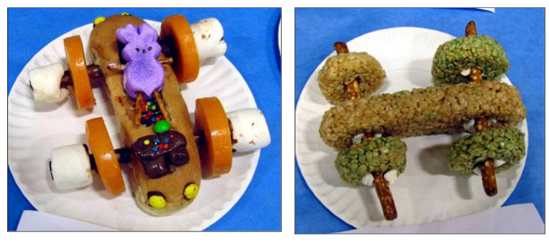

Student Engagement: How will you get and hold student attention?
Lesson Hook: Teacher will show various pictures of edible cars to spark a discussion among the class. Teacher may even show a quick edible car creation video from YouTube.

Students will be engaged through the variety of activities completed during this unit. Different learning styles are incorporated into the activity. Students will also be engaged through the use of the 1:1 computers in the classroom and will work collaboratively with their peers.

Differentiation: (How will you adjust the lesson to appropriately challenge ALL students?)
Students will be grouped prior to the lesson by the teacher based on ability level and behavior issues.
Differentiation will occur through the natural engineering design process that incorporate a variety of learning styles. Two versions (levels) of the worksheet will be provided.

IEP/504 Modifications/Accommodations: (What curriculum modifications and/or classroom accommodations will you make for Students with Disabilities in your class? Be as specific as possible.)
-Hear instructions orally and be given a written list of instructions
-Give responses in an oral/written form
-Work in a different setting (fewer distractions)
-Take more time to complete the task/frequent breaks
-Use an alarm to help with time management
-Answer fewer/different questions
-Individual redirection

Suggestions for Consideration and Reflection:
What went well?

What did you learn?

What adjustments will you make moving forward?

What did your assessment results indicate?

Was this lesson rigorous enough to engage all students? Explain.

Were the modifications/accommodations sufficient to facilitate meaningful participation for challenged students?

Would you be willing to share this lesson with colleagues? If no, why not?

